Longitudinal Genomic Surveillance of avian pathogenic Escherichia coli in Norwegian Breeder and Broiler Flocks (2018–2025)
Camilla, Inger, Jannice, Anne Margrete, Bjarne (må avklare om han er interessert), Basma, Eve, Solveig, Silje, Eva Lena, Cecilia (?), patolog (?)

Introduction
Colibaccillosis, caused by avian pathogenic Escherichia coli (APEC), is a major challenge to the poultry industry worldwide as it is often associated with high mortality rates, impacts animal welfare and causes significant economic loss. APEC causes both local and systemic infections in poultry, including airsacculitis, pericarditis and septicemia.
APEC has been characterized as a highly diverse pathogroup, encompassing a broad range of phylogenetic backgrounds, serotypes and sequence types (STs). Commonly reported STs include ST117, ST95, ST23 and ST131, although their distribution varies geographically and temporally (ref). Similarly, serogroups such as O1, O2 and O78 are frequently associated with colibacillosis, but no single lineage or serotype is consistently dominant across all production systems. The pathogenicity of APEC is associated with a large repertoire of virulence-associated genes (VAGs), many of which are encoded on plasmids, particularly ColV plasmids, including genes involved in adhesion, iron acquisition, serum resistance and toxin production (ref). However, no universal genetic marker has been identified that can reliably distinguish pathogenic from commensal E. coli in poultry, complicating both diagnostics and surveillance. This highlights the importance of whole genome sequencing (WGS)-based approaches for comprehensive characterization of APEC populations.
In recent years, an increase in poultry flocks diagnosed with colibaccillosis has been reported in several Nordic countries (refs). Notably, outbreaks affecting multiple farms have been linked to specific clonal lineages, suggesting dissemination through the breeding pyramid. For example, the ST117 O78:H4 lineage has been identified across broiler and breeder flocks in multiple Nordic countries, with genomic studies indicating vertical transmission from parent or grandparent stock to broiler production flocks. Similarly, large-scale outbreaks in Finland (2015 and 2021) were associated with dominant clonal lineages such as ST117 (serotype?) and ST23 (Serotype?), affecting a high proportion of investigated flocks and demonstrating the capacity of specific APEC strains to spread widely across production systems (ref). Studies from Denmark have also highlighted the substantial burden of APEC-related disease, including both sporadic and outbreak situations, as well as considerable diversity of isolates present even in apparently healthy flocks (ref). Legge inn en nylig referanse fra Sverige også? Together, these findings underscore the dynamic/complex epidemiology of APEC in the Nordic region and the importance of coordinated surveillance efforts.
The Nordic poultry production system, including Norway, is characterized by a vertically integrated breeding pyramid with a limited number of parent and grandparent flocks supplying a large proportion of the production animals. This structure may facilitate dissemination of successful APEC clones across geographically separated farms when introduced at higher levels of the pyramid, while also offering opportunities for efficient control if transmission routes are identified and managed.
APEC transmission is considered to occur through a combination of vertical and horizontal routes. Vertical transmission from breeder flocks or higher levels in the breeding pyramid to broiler production flocks has been demonstrated for specific clonal lineages (ref), while horizontal transmission within and between flocks may occur via the environment, management practices and contaminated equipment or personnel (ref). The relative contribution of these routes likely varies between production systems and over time and remains an important knowledge gap.
In Norway, colibacillosis is an important cause of mortality in broiler production, as reported by Kravik et al. (ref) in recent years. Previous genomic studies of Norwegian broiler flocks have demonstrated a diverse APEC population, with STs such as ST23, ST429, ST95 and ST117 frequently associated with disease (refs). These studies have also identified both within-flock diversity and possible between-flock transmission events, including outbreaks involving closely related isolates across farms, highlighting the value of WGS in combination with epidemiological data to identify potential outbreaks (ref). Despite these advances, there remains limited longitudinal data integrating breeder and broiler levels, and a need to better understand persistence, transmission pathways and population dynamics over time (ref).
The aim of this study was to characterize the long-term population dynamics of APEC in Norwegian broiler and breeder production, identify dominant APEC variants associated with disease, and investigate evidence of transmission across different levels of the production pyramid.

Materials and methods

Sample collection
Avian pathogenic E. coli isolates were obtained from clinical submissions to the Norwegian Veterinary Institute (NVI). Isolates originated either from routine diagnostics of poultry flocks submitted by field veterinarians and the poultry industry or from ongoing research projects. Only isolates from commercial broiler- or breeder flocks were included in this study. A description of all isolates can be found in Supplementary table 1. Notably, the collection of APEC isolates was skewed, as active collection through research projects (2018-2022) and active surveillance of APEC (2024-2025) contributed with a larger number of isolates some years.
An APEC diagnosis was based on detection of typical macroscopic lesions compatible with colibacillosis, and the detection of pure- or dominating culture of E. coli from inner organs or skin.
APEC isolates originated from clinical submissions to the section of pathology (carcasses and organ samples, n=109 submissions) or section of bacteriology (swabs, n=152 submissions) at NVI from January 2018 to December 2025. In addition, APEC isolates collected in the research project APEC-SEQ (the Research Council of Norway grant number 280385) in 2018-2021 were included (swabs, n=96 submissions) (sett inn ref fra Ingers publikasjoner) and an internal project APEC Pilot (swabs, n=21 submissions). Swab samples, submitted directly to section for bacteriology or collected from carcasses and/or inner organs of diseased birds at section for pathology, were analysed at section for bacteriology. Briefly, swabs were cultured on two blood agar (BA) plates and one Heart Infusion Agar (HIA) supplemented with 6% lactose-saccharose solution, and incubated anaerobically (one BA plate), in 5% CO2 (one BA plate) and aerobically (HIA) at 37 ±1 º C for 16-24 hours. Pure- or dominating growth of E. coli was interpreted as colibacillosis. Isolates were confirmed as E. coli by a positive indole test and/or by MALDI-TOF (Bruker). All isolates were stored at -80ºC in the biobank at NVI.

DNA extraction
Total genomic DNA was extracted manually using the QIAmp® DNA Mini Kit (Qiagen) following the manufacturer’s instructions, including the optional RNase A step. The final elution buffer was 100 µL 10 mM Tris HCl, pH 8. DNA purity was determined using NanoDrop Nucleic Acid Quanitication (Thermo Fischer) or MySpec (VWR). The DNA yield was determined using Qubit or Tecan Spark Fluorometer (Tecan Trading AG) with the Qubit dsDNA broad range kit and the DNA quality was assessed using MySpec (VWR).

Library preparation and whole genome sequencing
Whole genome sequencing was performed in-house at the Norwegian Veterinary Institutes core facility for high throughput sequencing or at the Norwegian Sequencing Centre (https://www.sequencing.uio.no/). Isolates were prepared using NexteraTM DNA Flex library preparation kit (Illumina) or Illumina DNA Prep library preparation kit (Illumina) and sequenced on an Illumina MiSeq (300 bp paired-end reads) or Illumina NextSeq 500 (150 bp paired-end-reads).

Bioinformatic analysis

Raw read quality, trimming and genome assembly
Initial quality control of the data was performed using the quality control pipeline in the in-house data analysis system VIGAS/P (ref). This included assessment of read quality using fastqc v 0.73 (https://www.bioinformatics.babraham.ac.uk/projects/fastqc/) and contamination check using Kraken2 v 2.1.3 (ref) with the database Minikraken v2. Reads were assembled using the draft_genome track in the Assemblage pipeline (ref). Briefly, reads were trimmed using TrimGalore v xx (ref) and downsampled to a target coverage of 100x by Rasusa v xx (ref) before assembly using Unicycler v xx (ref). Assembly quality was assessed using Quast v xx (ref).

Prediction of MLST, serotype, virulence-associated and antimicrobial resistance genes
Multilocus sequence type (MLST) was determined using mlst by T. Seemann (github.com/tseemann/mlst) using the Enterobase database (ref) and the Achtman scheme for E. coli (Ref). We used VirulenceFinder v 2.0 (ref) with default settings (threshold 90% ID, 60% minimum length) to detect virulence genes in the included isolates, and SerotypeFinder v 2.0 (ref) to determine O:H serotypes. Presence of point mutation or acquired genes encoding antimicrobial resistance (AMR) was investigated using ResPointFinder (ref), (ResPointFinder tool version: 4.4.2, ResFinder DB version: 2.2.1, PointFinder DB version: 4.0.1 DisinFinder DB version 2.0.1). All these tools were run in the in-house Galaxy platform, VIGAS/P.
“APEC variants” were defined based on ST, serotype and presence of selected virulence genes (i.e. iutA, iss, papC, iucC, tsh, irp2, ompT, hlyF, iroN, astA and cvaC) (ref).

Phylogenetic analyses
Isolates with specific ST-serotype combinations detected in at least five submissions from parent flocks and five submissions from broiler flocks during the study period were included in SNP analysis to determine the genetic relatedness between isolates. SNP analysis was performed in the ALPPACA pipeline (ref) using the core_genome track. Briefly, ParSNP v 2.1.3 (ref) was used to construct a SNP alignment using the longest assembly from the respective ST-serotype combinations as reference genome. Recombinant regions were identified by Gubbins v 3.4 (ref) using the GTRGAMMA model and RaxML as initial tree builder. Putative recombinant regions were masked using Maskrc-svg v 0.5 (ref) before filtering using snp-sites v 2.5.1 (ref). IQ-TREE v 2.4.0 (ref) was used to create a maximum-likelihood phylogeny. ModelFinder (ref) was used to identify the most suitable evolutionary model, and UFBoot2 (ref) to evaluate branch support (ref). Finally, snp-dists v 0.8.2 (ref) was used to calculate pairwise SNP distances using the recombinant-filtered alignment. Phylogenetic trees were annotated and visualized in R v. xx (ref) using the ggtree package v xx (ref).

Statistics
Data management and summary statistics was done in R v. xx (supplementary material?) (ref).

Data availability
Sequence data are available in the European Nucleotide Archive (ENA) under bioprojects PRJEB43441, PRJEB55163 and xx. Individual accession numbers per isolate are available in the supplementary table 1.

Results
Three isolates did not pass the QC check and were excluded due to poor sequencing quality.
In total, 884 isolates were included in the study. These originated from 250 different producers/farms and 378 different sample submissions. The number of submissions per farm varied from one to seven with a median of one, while number of isolates per producer varied from one to 19 with a median of three. Seventy-five of the producers only contributed one E. coli isolate from diseased animals/flocks. The number of isolates included per submission varied from one to 15, with a median of two isolates. In total, 267 submissions and 650 isolates were from broilers and 111 submissions and 234 isolates from broiler parents (Table 1).
Table 1. Number of producers, submissions and isolates from the different production types included in this study.
Production type | n producers | n submissions | n isolates
Broilers | 187 | 267 | 650
Broiler parents | 63 | 111 | 234
Total | 250 | 378 | 884

In total, 88 different STs were observed among the included isolates. The most common ST was ST23 (n=255), followed by ST117 (n=83) and ST95 (n=67). The top ten STs accounted for 72.9% (n=645) of the isolates. Thirty-eight STs were only represented by single isolates.
The most commonly observed serotypes were O78:H4 (n=251), followed by O2/O50:H1 (n=71) and O2/O50:H5 (n=49). Serotype O78:H4 was observed in ST23 (n=244) and ST117 (n=7), while O2/O50:H1 was detected in ST429 (n=53) and ST135 (n=18). Further, serotype O2/O50:H5 was reported in five different STs, namely ST95 (n=36), ST140 (n=5), ST355 (n=4) and STs 12959 and 16710 (n=2 each).
Of the 884 isolates included, 870 carried one or more virulence gene(s) associated with APEC. The most commonly observed combination of genes was cvaC, hlyF, iroN, irp2, iss, iucC, iutA, ompT, tsh (n=301), which was detected in four different STs, namely ST23 (n=242), ST429 (n=52), ST140 (n=5) and ST69 (n=2). The second most frequent combination was papC in combination with all the virulence genes above (n=58), detected in ST69 (n=29), ST117 (n=23), ST88 (n=3) and ST95 (n=3).
The most frequently observed combinations of ST, serotype and virulence genes are shown in Figure 1. When all three factors are taken into account, ST23-O78:H4-cvaC, hlyF, iroN, irp2, iss, iucC, iutA, ompT, tsh was the most common combination (n=242), followed by ST429-O2/O50:H1- cvaC,hlyF,iroN,irp2,iss,iucC,iutA,ompT,tsh (n=52).
In the majority of included isolates (590/884, 66.7%), no point mutations or acquired genes encoding antimicrobial resistance were detected. The most commonly observed AMR genotype was the point mutation S83L in gyrA encoding quinolone resistance (n=63, 7.1%), followed by sul2 (n=52, 5.9%) encoding sulfamethoxazole resistance and bla_{TEM-1B} (n=46, 5.2%) encoding ampicillin resistance. A full overview of the acquired AMR genes and point mutations discovered is presented in Supplementary table X.

Figure 1: Eight most frequently observed variants of avian pathogenic Escherichia coli (APEC) based on combination of multilocus sequence type, serotype and selected virulence genes, observed in a minimum of 10 submissions (total 378 submissions) from broilers and broiler parents collected between 2018-2025 in Norway. The virulence-associated genes hlyF, iroN, iss, iucC, iutA and ompT were present in all APEC variants included and are therefore excluded from the figure. Inkludere rød og grønn
A total of 31 producers provided three or more submissions from 2018-2025. E. coli isolates with the same ST/serotype combination were detected in at least two submissions from different flocks in submissions from 15 of these producers.
For submissions where multiple isolates were included (n=207), the same APEC variant (ST-serotype combinations) were normally observed in all (n=113, 54.6%) or the majority (>50%) (n=42, 20.3%) of the isolates. For the remaining 52 (25.1%) submission, all or most isolates were different APEC variants. For producers providing multiple submissions (n=77), the same APEC variant(s) were observed across submissions for 26 producers (33.8%) for at least one isolate in at least two submissions. In submissions from the remaining 51 producers (66.2%), we observed different APEC variants in different submissions.
For isolates originating from broilers (n=650), the most common APEC variant observed was ST23-O78:H4 (n=224, 34.5%) followed by ST429-O2/O50:H1 (n=51, 7.8%). For isolates from broiler parents (n=234), the APEC variant dominating was ST117-O24:H4 (n=36, 15.4%) followed by ST131-O25:H4 (n=21, 9.0%). In total, 100 different APEC variants were detected among isolates from broilers and 67 among isolates from parents. Of these, 33 APEC variants were detected in both production forms, while 67 and 34 variants were only detected in broilers and parents, respectively (Supplementary File X).
Phylogeny
Three ST-serotype combinations were detected in at least five submissions from both parent- and broiler flocks during the study period and included in SNP analysis. The three combinations were ST23-O78:H4 (118 submissions, 244 isolates), ST95-O2/O50:H5 (22 submissions, 36 isolates) and ST131-O25:H4 (32 submissions, 46 isolates).
ST23-O78:H4 isolates and ST95-O2/O50:H5 varied overall with 0-43 and 0-81 SNPs, respectively, both with coverage >91%. ST131- O25:H4 varied with 0-320 SNPs between isolates with 90.9% coverage.
ST23-O78:H4 isolates were detected between 2021 and 2023 and originated from 105 submissions from broiler flocks and 13 submissions from parent flocks. Clusters including isolates from both parent- and broiler flocks were detected with isolates differing by a limited number of SNPs (i.e. <11) (Figure A).
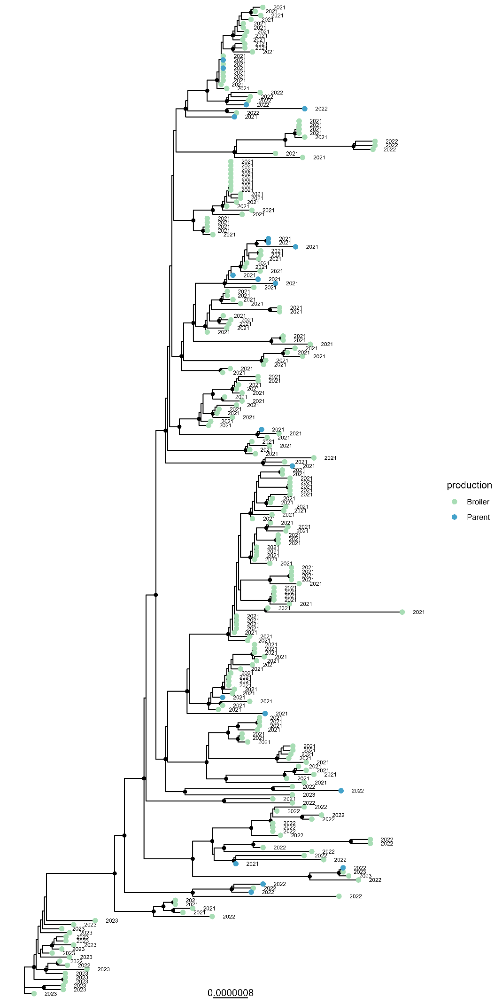
Figure A: Core genome SNP tree of 244 Escherichia coli multilocus sequence type 23, serotype O78:H4. The isolates were collected from broilers (n=224) and broiler parents (n=20) in Norway from 2021 to 2023. Tip-points are coloured based on production type, while the label indicated year of collection. SNP-ranges are indicated for closely related isolates.
ST95-O2/50:H5 isolates were detected between 2019-2025 and originated from 16 submissions from broiler flocks and 6 submissions from parent flocks. Genomes generally clustered based on isolation year. Three clusters including E. coli from both broiler- and parent flocks were detected (Figure X). Two clusters included one isolate from broiler flocks and one isolate from parent flocks, while the third cluster included one isolate from parent flock and four isolates from broiler flocks, all from 2022.
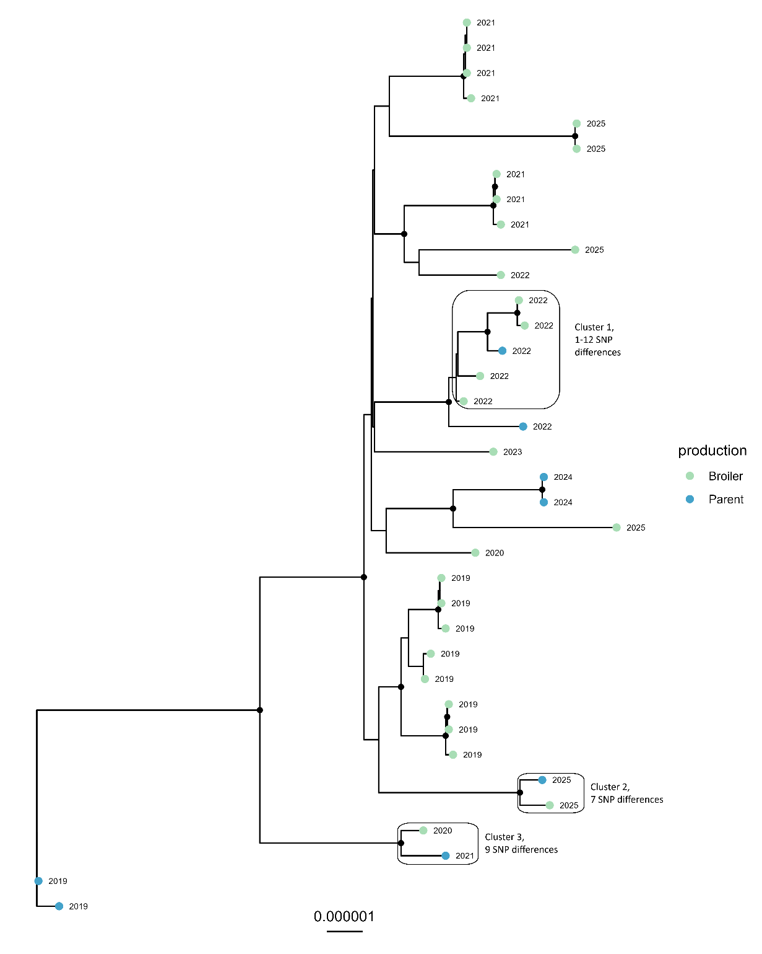
Figure X: Core genome SNP tree of 36 Escherichia coli multilocus sequence type 95, serotype O2/O50:H5. The isolates were collected from broilers (n=28) and broiler parents (n=8) in Norway from 2019 to 2025. Tip-points are coloured based on production type, while the label indicated year of collection. Clusters and SNP-ranges are indicated for closely related isolates.
ST131-O25:H4: Isolates were detected from 2019-2025 and originated from 17 submissions from broiler flocks and 15 submissions from parent flocks. Overall, up to 320 SNP differences. Two distinct clades? Bottom clade dominated by isolates from parent flocks, while the top clade includes more broiler isolates. Three clusters with isolates from both parent- and broiler flocks (Figure Y).
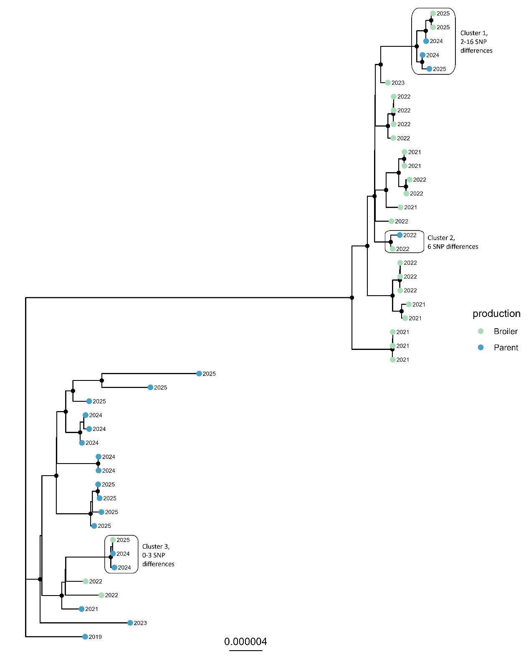
Figure Y: Core genome SNP tree of 46 Escherichia coli multilocus sequence type 131, serotype O2/O50:H5. The isolates were collected from broilers (n=25) and broiler parents (n=21) in Norway from 2019 to 2025. Tip-points are coloured based on production type, while the label indicated year of collection. Clusters and SNP-ranges are indicated for closely related isolates.
Discussion
Main findings
This study provides the first longitudinal genomic characterization of APEC associated with colibacillosis in Norwegian broiler and breeder production over an eight-year period. Despite substantial genomic diversity, a limited number of APEC variants accounted for a large proportion of submissions, suggesting that certain variants are particularly successful within the Norwegian poultry production system. Furthermore, genomic analyses identified closely related isolates from both breeder and broiler flocks, supporting the hypothesis that some lineages may disseminate through the production pyramid. Finally, the overall occurrence of AMR genes was low, consistent with the generally low antimicrobial usage in Norwegian poultry production. Collectively, these findings highlight the complex epidemiology of APEC in Norwegian broiler production and suggest that a limited number of successful APEC variants contribute to disproportionately to the burden of colibacillosis.
Population structure of APEC in Norwegian poultry
Despite the considerable diversity observed among APEC isolates included in this study, a limited number of APEC variants accounted for a substantial proportion of submissions. In total, 88 different STs and a broad range of serotypes and virulence profiles were identified, highlighting the heterogenous nature of APEC and supporting previous studies that colibacillosis can be associated with a genetically diverse E. coli population (ref). However, when combining ST and serotype, a relatively small number of APEC variants dominated the dataset. In particular, ST23-O78:H4 was by far the most frequently observed APEC variant, followed by ST429-O2/O50:H1, while other variants such as ST117-O24:H4, ST95-O2/O50:H5 and ST131-O25:H4 were also regularly detected.
The predominance of ST23-O78:H4 has been described in a previous publication (ref Inger), where ST23, ST429 and ST95 were identified among the most common causes of colibacillosis in the years 2018-2021 (ref Inger). Similar observations have been reported from other Nordic countries (ref). In Finland, both ST23 and ST117 have been associated with large colibacillosis outbreaks affecting multiple flocks (ref), while ST117-O78:H4 was identified as a major disease-associated lineage in broilers and breeder flocks across several Nordic countries during 2014-2016 (ref). Together, these studies suggest that, despite substantial genetic diversity, a limited number of APEC variants are repeatedly associated with disease in Nordic poultry production systems.

It should, however, be noted that the isolate collection was not generated through a systematic national surveillance. More than half of the isolates originated from targeted sampling associated with research projects and disease investigations, including extensive sampling during a period with increased occurrence of ST23-associated colibacillosis. Consequently, the high proportion of ST23-O78:H4 observed in this study is likely influenced by sampling strategy and should not be interpreted as a direct estimate of the prevalence of this variant in the Norwegian poultry population.
Dissemination through the poultry production pyramid and repeated introduction of APEC variants
Several of the dominant APEC variants identified in this study were detected in both broiler and breeder production. Furthermore, phylogenetic analysis of ST23-O78:H4, ST95-O2/O50:H5 and ST131-O25:H4 revealed clusters of closely related isolates originating from both production levels. Although these findings do not constitute direct evidence of vertical transmission, they are consistent with dissemination of specific APEC variants through the poultry production pyramid.
In particular, ST117-O78:H4 was shown to disseminate between breeder and broiler flocks across multiple Nordic countries with common grandparent flocks (ref, Ronco). Recent studies from Finland have also linked widespread colibacillosis outbreaks to clonal APEC variants detected at different levels of the breeding pyramid (ref). Together with these previous findings, our results support the hypothesis that breeder flocks may act as an important source of APEC variants affecting broiler production.
For producers with multiple submissions, different APEC variants were often detected in different production rounds, suggesting that long-term farm-level persistence may be less important than repeated introduction of new variants. Dissemination through the production pyramid could partly explain this pattern, as new variants may be introduced with incoming flocks rather than persisting locally between production cycles.
Taken together, these findings indicate that repeated introduction of APEC variants with new flocks may play a more important role in the epidemiology of colibacillosis than long-term persistence of individual variants at the farm level in the Norwegian broiler production.
Multiple APEC lineages within the same submission or flock
Interestingly, different APEC variants were observed in approximately 25% of submissions where more than one isolate was characterized. This indicates that some cases of colibacillosis may involve multiple co-circulating APEC variants within the same flock. In contrast, a single APEC variant was detected in all or the majority of isolates from many submissions, indicating that some outbreaks may be dominated by a single disease-causing strain. A previous study (REF) has suggested that colibacillosis can be caused either by one highly virulent APEC variant or a combination of less virulent APEC variants, which is further supported by our findings. Together, these findings underline the complex epidemiology of colibacillosis.
The presence of multiple E. coli variants within individual submissions also emphasizes the challenges associated with identifying the disease-causing strain in routine diagnostics and outbreak investigations.
These findings support the characterization of multiple E. coli isolates from several birds when investigating colibacillosis outbreaks within a flock.
It should also be noted that bacteriological sampling from newly hatched chicks and very young birds may be challenging. Maintaining aseptic conditions during necropsy can be difficult, increasing the risk of contamination and potentially contributing to the detection of incidental E. coli variants that are not involved in disease development.
Virulence-associated genes and antimicrobial resistance

Several of the dominant APEC variants identified in this study shared similar virulence profiles and carried VAGs commonly linked to APEC pathogenicity. In particular, the two most frequently detected variants, ST23-O78:H4 and ST429-O2/O50:H1, shared an identical virulence profile consisting of cvaC, hlyF, iroN, irp2, iss, iucC, iutA, ompT and tsh. Many of these genes have previously been associated with APEC pathogenicity, and many are commonly located on ColV-associated plasmids. Similar virulence profiles were also observed among genetically distinct APEC variants, suggesting that virulence-associated plasmids may disseminate across different E. coli strains and contribute to the success of multiple APEC variants.

Variation in VAG content was also observed among isolates belonging to the same ST and serotype. While this may reflect both true biological variation and methodological limitations associated with assembly-based gene detection. Consequently, some genes may be present but not detected in fragmented genome assemblies.
Nevertheless, the observed variation in virulence profiles further highlights the challenges associated with defining APEC based solely on genetic markers. Although several VAGs were frequently detected among disease-associated isolates, no single gene or virulence profile was consistently present in all APEC variants. Together with previous studies, these findings support the concept of APEC as a heterogeneous pathotype rather than a genetically well-defined group.
The overall occurrence of AMR genes was low among the isolates included in this study. This finding is consistent with the limited use of antimicrobials in Norwegian broiler production and the generally favourable AMR situation reported in Norwegian poultry (ref – NORM-VET). The most frequently observed resistance determinants were the gyrA S83L mutation, sul2, and bla_{TEM-1}. In contrast to reports from other poultry-producing countries (ref), AMR does not currently appear to be a major characteristic of APEC in Norway.
Strengths and limitations
The present study has several strengths. To our knowledge, it represents the first longitudinal genomic investigation of APEC associated with colibacillosis in Norwegian poultry production, covering an eight-year period and including isolated from both broiler and breeder flocks. The large isolate collection, combined with WGS and access to epidemiological metadata, enabled analyses of population structure virulence profiles and genetic relatedness across production levels.
Several limitations should, however, be considered when interpreting the findings. First, sampling was not performed as a part of a systematic national surveillance programme. A substantial proportion of isolates originates from targeted sampling associated with research projects and disease investigations, including periods with increased sampling during ST23-associated outbreak. Consequently, the relative abundance of individual APEC variants in the present dataset may not accurately reflect their prevalence in the Norwegian poultry population.
Second, sampling intensity varied between years and production types, with broiler isolates accounting for the majority of the collection. In addition, the number of isolates characterized per submission varied considerably, potentially influencing the probability of detecting multiple APEC variants within individual flocks.
Finally, only disease-associated isolates were included in the study. The occurrence and diversity of APEC-associated virulence genes among commensal E. coli populations in healthy poultry therefore remain unknown. Furthermore, detailed pedigree information linking all breeder and broiler flocks was not available, preventing direct verification of transmission pathways within the production pyramid. In addition, information on poultry hybrid was not consistently available, limiting our ability to evaluate whether specific APEC variants were associated with particular breeding lines.
Conclusion and future perspectives
In conclusion, the present study demonstrates that APEC associated with colibacillosis in Norwegian poultry production is genetically diverse, comprising a broad range of STs, serotypes and virulence profiles. Despite this diversity, a limited number of APEC variants accounted for a substantial proportion of submissions, with ST23-O78:H4 emerging as the most prominent variant during this study period.
Furthermore, the detection of closely related isolates in broiler and breeder production supports the role of the poultry production pyramid in the dissemination of specific APEC variants. Finally, generally low occurrence of AMR genes reflects the favourable AMR situation on Norwegian poultry production.
Several important knowledge gaps remain. While this study focused on APEC isolates from colibacillosis, little is known about the occurrence and diversity of APEC-associated variants and related VAGs within the intestinal E. coli population of healthy poultry. It remains unclear whether many of the variants identified represent primary pathogens, opportunistic pathogens already present in the intestinal microbiota, or incidental findings associated with disease. Environmental and host-associated factors may also influence the transition from intestinal colonization to systemic infection.
Future studies should therefore focus on identifying genetic and ecological characteristics that distinguish disease-associated APEC from commensal E. coli. Comparative genomic approaches, including genome-wide association studies (GWAS), may improve our ability to define and detect APEC. In addition, integration of genomic data from breeder, hatchery and broiler production could provide further insight into transmission pathways and support targeted surveillance and control strategies.

